Requirements:

* A clickable button on the Admin page that redirects to a page with a list of reports.
* Clicking any one of the reports will directly download a PDF of that report.

Example:

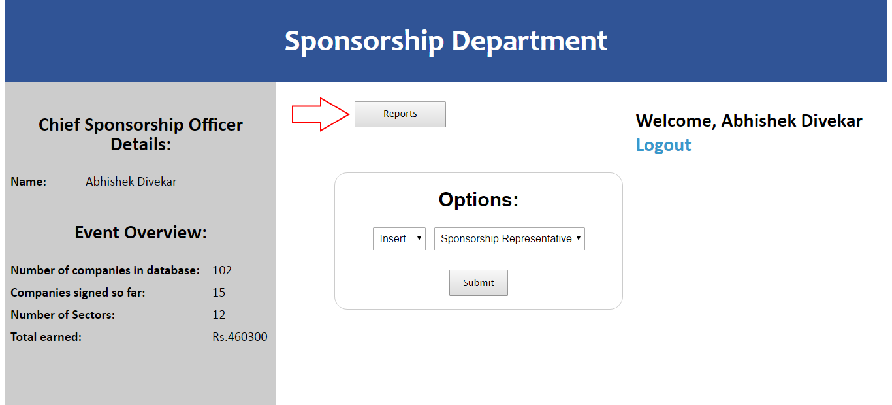

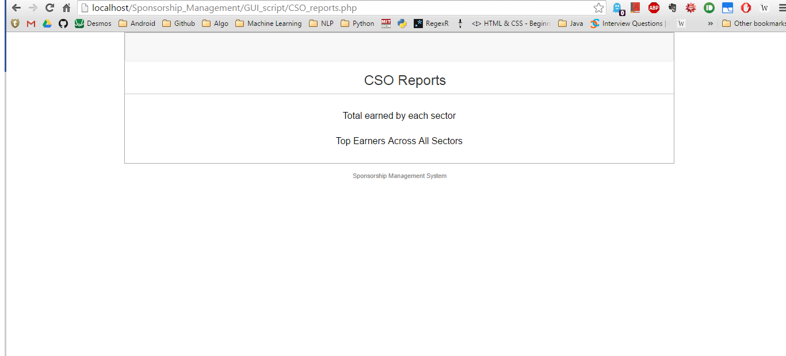

And on clicking the “Total Earned By Each Sector” link:

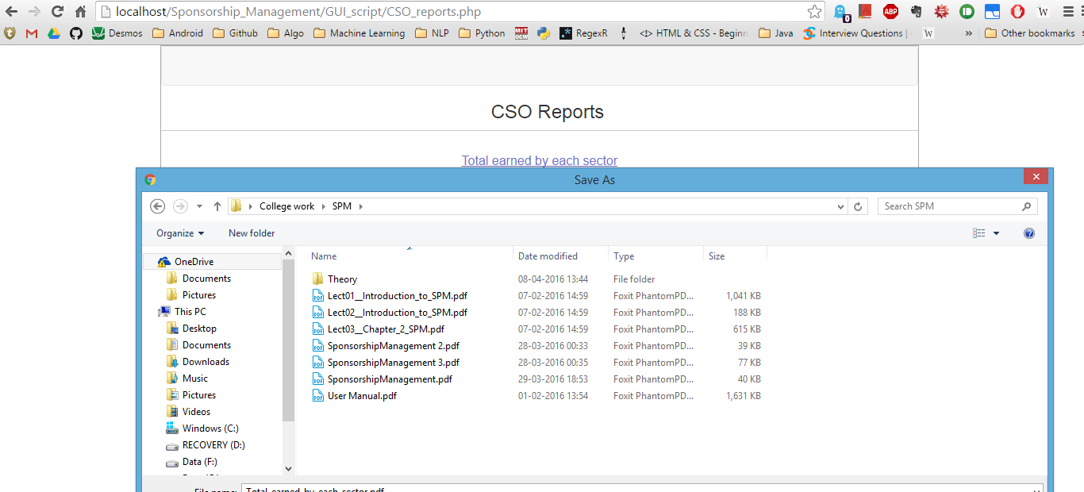

I have done mine in Reportico, and it’s not too difficult.

* First, download Reportico. It will be a zip file. Unzip it in the directory where you have your admin page.
* Reportico is an open-source tool, and it provides all the source code directly as multiple .php files, rather than a single .exe file (which is in binary ones and zeros). This is good for us for two reasons:
  + We can host it on the server without having to install any programs from .exe files (which the servers do not allow, usually).
  + It means that we can modify the tool however we want to and add our own source code to do special functions (no required for this tutorial, just thought you might want to know).
* Once you’ve downloaded Reportico and unzipped it into the folder where your admin.php page is, your directory structure should look like this (my admin.php page is CSO.php, yours might be hostpital_admin.php or canteen_admin.php or whatever. According to the profs, we only have to make reports for the admins):

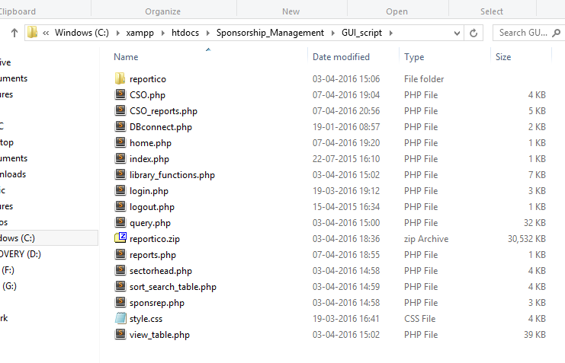

If you notice, this is all done inside my xampp/htdocs/ directory, meaning now I can run Reportico by visiting the browser (after starting Xampp).

* If you open a browser (and start Xampp or Wamp) and go to localhost/<your project path>/reportico/index.php, you can run the reportico tool. E.g. I would go to localhost/Sponsorship_Management/GUI_script/reportico/index.php (Look at the above photo to understand).
* Now, you must follow the steps mentioned on the reportico website to make a new project and make some reports for it.   
  It is important that you don’t set a project password (which lets anyone **view** reports), but you DO set an admin password (which lets anyone **make, design and customize** reports).

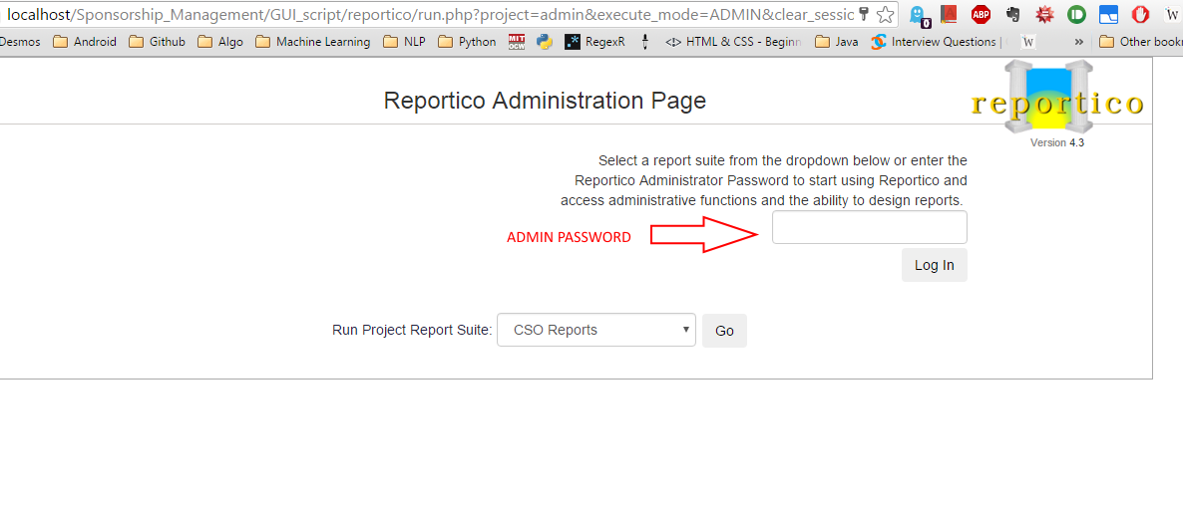

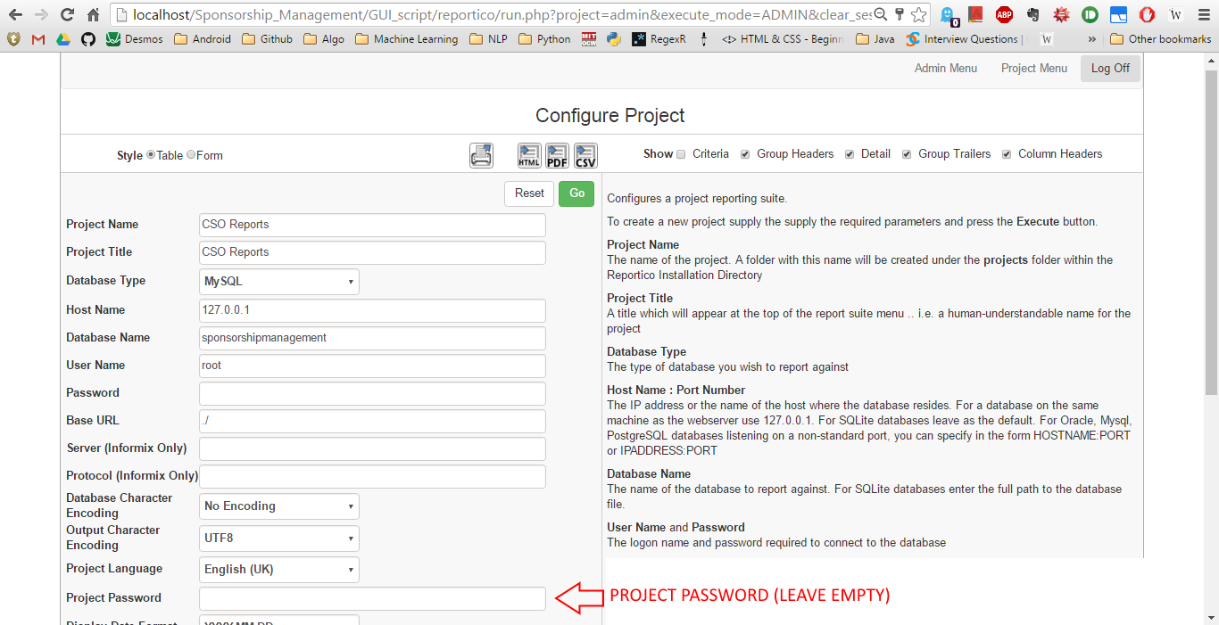

* Now, you can follow the steps over here: <http://www.reportico.org/swsite/site/doc/reportico/tutorial_reportico.using.pkg.html> to make your report a link which views the report directly rather than going through the reportico tool. Then you can access saved reports via url by just using the Project name and Report name. You’ll have to use target_format=PDF to get it as a PDF.
* After this, you can upload your entire project via Filezilla (the reportico tool takes 10-15 minutes to upload, it’s like 30 MB of code files).

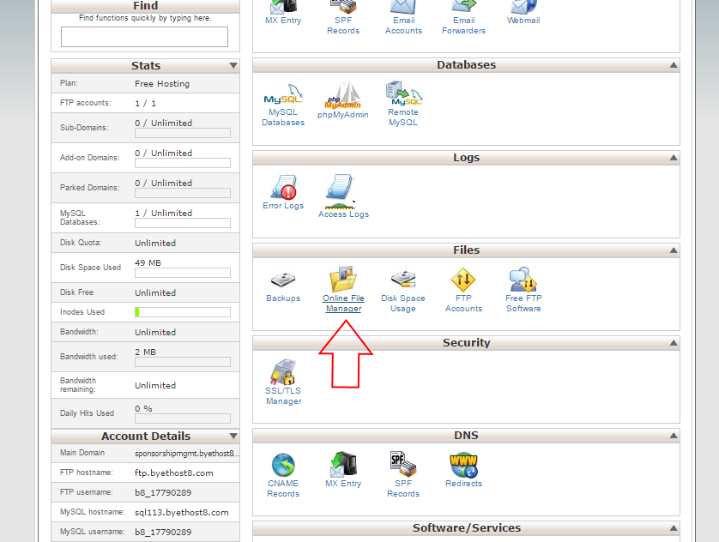

Use this to get the FileZilla details

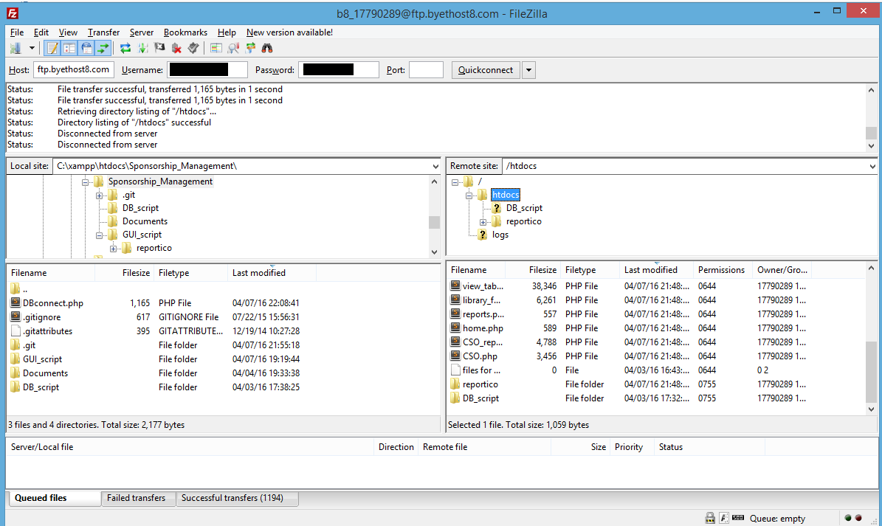

FileZilla example